Network Devices
Linux内核网络部分有两个主要的抽象，一个是Packet的抽象——sk_buff，网络适配器的抽象——Network Device.
每个通信终端可能有不同的网络适配器（网卡），它们的配置以及驱动程序都是不同的。另外多个Protocol Instance要使用网络适配器的服务，为了每个Protocol Instance的实现与特定的适配器类型无关，Linux给出Network Device抽象，利用它来给上层提供统一的接口：
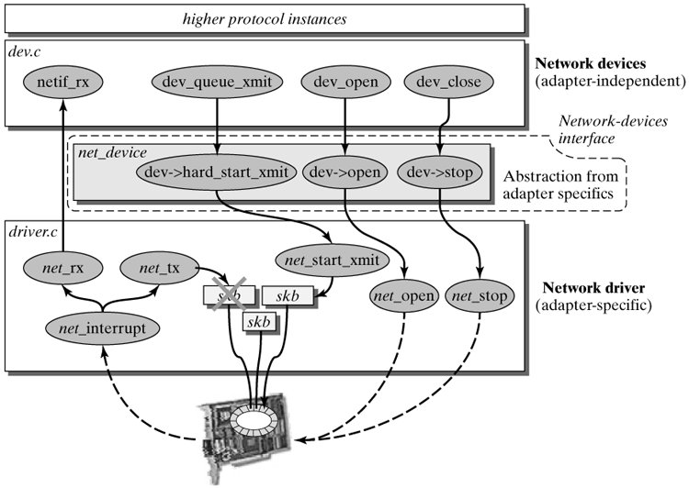
并不是Linux内核中所有网络设备都表示物理网络适配器。There are network devices, such as the loopback network device, that offer logical network functionality. The interface of network devices is also often used to bind protocols, such as the point-to-point protocol (PPP).

1.1 Network Device Interface
网络设备与字符设备和块设备最大的不同在于它们在设备文件系统/dev中没有相应的节点。
补充资料：
字符设备是一种字节流设备，对设备的存取只能按顺序按字节存取而不能随机访问，字符设备没有请求缓冲区，所有的访问请求都是按顺序执行的。可以在一次I/O操作中传送任意大小的数据。
块设备能够随机（不需要按顺序）访问固定大小数据片（Linux以页为单位）。
（字符设备和块设备也有相应的char_device结构和block_device结构）
Cites: The same as character/block device, each net_device structure represents one network device.
struct net_device结构如下，这一节会介绍若干常用的字段：
struct net_device
{
char name[IFNAMSIZ];
unsigned long rmem_end, rmem_start, mem_end, mem_start, base_addr;
unsigned int irq;
unsigned char if_port, dma;
unsigned long state;
struct net_device *next, *next_sched;
int ifindex, iflink;
unsigned long trans_start, last_rx;
unsigned short flags, gflags, mtu, type, hard_header_len;
void *priv;
struct net_device *master;
unsigned char broadcast[MAX_ADDR_LEN], pad;
unsigned char dev_addr[MAX_ADDR_LEN], addr_len;
struct dev_mc_list *mc_list;
int mc_count, promiscuity, allmulti;
int watchdog_timeo;
struct timer_list watchdog_timer;
void *atalk_ptr, *ip_ptr, *dn_ptr, *ip6_ptr, *ec_ptr;
struct Qdisc *qdisc, *qdisc_sleeping, *qdisc_list, *qdisc_ingress;
unsigned long tx_queue_len;
spinlock_t xmit_lock;
int xmit_lock_owner;
spinlock_t queue_lock;
atomic_t refcnt;
int features;
int (*init)(struct net_device *dev);
void (*uninit)(struct net_device *dev);
void (*destructor)(struct net_device *dev);
int (*open)(struct net_device *dev);
int (*stop)(struct net_device *dev);
int (*hard_start_xmit) (struct sk_buff *skb,
struct net_device *dev);
int (*hard_header) (struct sk_buff *skb,struct net_device *dev,unsigned short type,void *daddr,void *saddr, unsigned len);
int (*rebuild_header)(struct sk_buff *skb);
void (*set_multicast_list) (struct net_device *dev);
int (*set_mac_address) (struct net_device *dev, void *addr);
int (*do_ioctl)(struct net_device *dev, struct ifreq *ifr, int cmd);
int (*set_config)(struct net_device *dev, struct ifmap *map);
int (*hard_header_cache) (struct neighbour *neigh, struct hh_cache *hh);
void (*header_cache_update) (struct hh_cache *hh, struct net_device *dev, unsigned char *haddr);
int (*change_mtu)(struct net_device *dev, int new_mtu);
void (*tx_timeout) (struct net_device *dev);
int (*hard_header_parse) (struct sk_buff *skb, unsigned char *haddr);
int (*neigh_setup) (struct net_device *dev, struct neigh_parms *);
struct net_device_stats* (*get_stats) (struct net_device *dev);
struct iw_statistics* (*get_wireless_stats) (struct net_device *dev);
struct module *owner;
struct net_bridge_port *br_port;
};
① General Fields of a Network Device：
- name is the name of the network device. When registering a network device, you can suggest a name, which should be unique. However, you can also let the system assign the ethn name automatically.
- next is used to concatenate several net_device structures. All network devices are managed in a singly linked linear list that starts with the pointer dev_base:
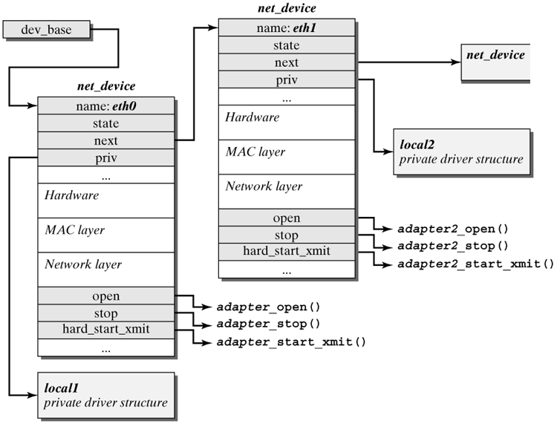
- owner is a pointer to the module structure of the module created by the net_device structure of this network device.
- state contains status information about the network device and the network adapter:
State | Specification
__LINK_STATE_PRESENT | Shows whether the network adapter physically existed.
__LINK_STATE_START | Shows whether the network adapter was opened with dev->open() (i.e., whether it was activated and can be used).
__LINK_STATE_XOFF | Shows whether the network adapter can accept socket buffers for transmission or its transmit buffers (which are normally organized as ring buffers) are already busy.
- trans_start stores the time (in jiffies) when the transmission of a packet started. If, after some time, the driver still hasn't received an acknowledgment to send the packet (ACK interrupt), then it can introduce appropriate actions. The kernel versions 2.4 and higher use a timer called watchdog_timer.
- last_rx should include the time (in jiffies) when the last packet arrived.
- priv is a pointer to the private data of a network device or to the private data of its driver. Private data contains those variables and structures that are required to manage a network adapter. They are not stored in the net_device structure, but they are normally specific to an adapter.
- qdisc refers to a structure of the type Qdisc, which mirrors the serving strategy of the current network device.用于拥塞控制。
② Hardware-Specific Fields：
- rmem_end, rmem_start, mem_end, mem_start: These fields specify the beginning and end of the common memory space that the network adapter and the kernel share. The location (mem_end - mem_start) designates the buffers for packets to be sent, and (rmem_end - rmem_start) designates the location for received packets. The size of the buffers indicates the amount of storage available on the card.
- base_addr: The I/O basic address ( I/O端口地址，用于对硬件中的寄存器寻址) is also set in the driver's probing routine during a search for a device. ifconfig can be used to display and set the value. In addition, the I/O basic address can be specified when loading most of the modules and as a kernel boot parameter.
- irq: The number of the interrupt of a network adapter is also set during the so-called probing phase of the driver or by explicitly specifying it when loading the module or starting the kernel. In addition, ifconfig can be used to modify the interrupt number during operation.
- dma contains the number of the DMA (Direct Memory Access) channel, if the device supports the DMA transfer mode.
③ Data on the Physical Layer：
对于以太网卡来说，下面这些字段由ethersetup()初始化。
- hard_header_length specifies the length (bytes) of the layer-2 packet header. This value is 14 for Ethernet adapters. 它并不包括到Network Adapter后加上的数据，比如校验和(4字节)。
- mtu is the maximum transfer unit, which specifies the maximum length of the payload of a frame (帧). Network layer protocols have to consider this value; they must not pass more octets to the network device. Ethernet has an MTU of 1492/1500 bytes, SLIP点对点链路的MTU为296bytes。
Notes: mtu主要用于限定网络层协议传递给链路层协议时的SDU的大小，对于以太网来说，mtu是1492/1500 bytes。
- tx_queue_len specifies the maximum length of the output queue of the network device. ether_setup() sets this value to 1000. tx_queue_len should not be confused with the buffers of the network adapter. A network adapter normally has an additional ring buffer for 16 or 32 packets.（网卡中的缓冲区）
- type specifies the hardware type of the network adapter.
- addr_len, dev_addr[MAX_ADDR_LEN], broadcast[MAX_ADDR_LEN]: These fields contain the data of the layer-2 address (以太网卡的Mac地址为6字节，最大的layer-2 address为8字节). addr_len specifies the length of the layer-2 address, which is stored in the dev_addr field. The third field contains the broadcast address (Mac广播地址，对以太网来说，MAC广播地址为0xFFFFFFFFFFFF), which can be used to reach all computers in the local network.
- dev_mc_list points to a linear list with multicast layer-2 addresses (多播的Mac地址). When the network adapter receives a packet with a destination address(多播的Mac地址) included in dev_mc_list, then the network adapter has to pass this packet to the upper layers. The driver method set_multicast_list is used to pass the addresses of this list to the network adapter. The hardware filter of this network adapter (if present) is responsible for passing to the kernel only those packets of interest to this computer.
- mc_count contains the number of addresses in dev_mc_list.
- watchdog_timeo and watchdog_timer are used to detect problems an adapter may incur when sending packets. For this reason, the watchdog_timer is initialized when a network device starts and always called after watchdog_timeo time units (jiffies). The handling routine dev_watchdog() checks whether or not watchdog_timeo time units have passed since the last transmission of a packet (stored in trans_start). If this is the case, then there were problems in the transmission of the last packet, and the network adapter has to be checked. To check the network adapter, the driver function tx_timeout() is called. If not much time has passed since the last start of a transmission, then nothing is done, except the watchdog_timer is started.
④ Data on the Network Layer
- ip_ptr, ip6_ptr, atalk_ptr, dn_ptr, and ec_ptr point to information of layer-3 protocols that use this network device. If the network device was configured for the Internet protocol, among others, then ip_ptr points to a structure of the type in_device, which manages information and configuration parameters of the relevant IP instance. For example, the in_device structure manages a list with IP addresses of the network device, a list with active IP multicast groups, and the parameters for the ARP protocol.
- family designates the address family of the network device. In the case of the Internet Protocol (IP), this field takes the constant AF_INET.
- pa_alen specifies the length of the addresses of the protocol used. IP addresses of the class AF_INET have the length 4 bytes.
- pa_addr, pa_braddr, and pa_mask describe the addressing of a network device on the network layer(IP地址).pa_addr contains the address of the computer or network device. pa_baddr specifies the broadcast address, and pa_mask includes the network mask. All three values are set by ifconfig when a network device is activated.
- pa_dstaddr specifies the address of the other partner in a point-to-point connection (e.g., PPP or SLIP).
- flags includes different switches. Some of them describe properties of the network device (IFF_ARP, IFF_MULTICAST,...); others output the current state (IFF_UP):
Flag | State/Property | Meaning
IFF_UP | State | The network device is activated and can send and receive packets.
IFF_BROADCAST | Property | The device is broadcast-enabled, and the broadcast address pa_braddr is valid.
IFF_DEBUG | State | This flag switches the debug mode on (currently not used by any driver).
IFF_LOOPBACK | Property | This flag shows that this is a loopback network device.
IFF_POINTOPOINT | Property | This is a point-to-point connection. If this switch is set, then pa_dstaddr should contain the partner's layer-3 address.
IFF_NOARP | Property | This device does not support the Address Resolution Protocol (ARP) (e.g., in point-to-point connections).
IFF_PROMISC | State | This flag switches the promiscuous mode on. This means that all packets currently received in the network adapter are forwarded to the upper layers, including those not intended for this computer. This mode is of interest for tcpdump only.
IFF_MULTICAST | Property | This flag activates the receipt of multicast packets. ether_setup() activates this switch. A card that does not support multicast should delete this flag.
IFF_ALLMULTI | Property | All multicast packets should be received. This is required when the computer is to work as multicast router. IFF_MULTICAST has to be set in addition.
IFF_PORTSEL | Property | Setting of the output port is supported by the hardware.
IFF_AUTOMEDIA | Property | Automatic selection of the output medium (autosensing) is enabled.
IFF_DYNAMIC | Property | Dynamic change of the network device's address is enabled (e.g., for dialup connections).
⑤ Device-Driver Methods
Some of these functions depend on the hardware of the network adapter and have to be set in the initialization function of the network driver; The other functions are specific to the MAC protocol used by the network adapter and can be initialized by special methods (e.g. eth_setup()). A function pointer not required can be initialized to NULL.
<与设备相关的函数>
- init() is used to search and initialize network devices. This method is responsible for finding and initializing a network adapter of the present type. Primarily, a net_device structure has to be created and filled with the driver-specific data of the network device or network driver. Subsequently, the network device is registered by register_netdevice().
- uninit() is called when a network device is unregistered (unregister_netdevice()). This method can be used to execute driver-specific functions, which may be necessary when a network device is removed. (Notes: New field for version 2.4, and currently not used by any driver).
- destructor() is called when the last reference to a network device was removed (dev->refcnt) (i.e., when no protocol instances or other components in the Linux kernel point to the net_device structure). This means that you can use the destructor() function to do cleanup work (e.g., free memory or similar things). (Notes: New field for version 2.4, and currently not used by any driver).
- open() opens (activates) a named network device. During the activation, the required system resources are requested and assigned. Note that this method can open only network devices that were previously registered. Normally, dev->open() is used in the dev_open() method which, in turn, is called by the ifconfig command. Upon successful execution of open(), the network device can be used.
- stop() terminates the activity of a network adapter and frees the system resources it has used. The network device is then no longer active, but it remains in the list of registered network devices (net_devs).
- hard_start_xmit() uses a packet (in the form of a socket buffer) over the network device. If successful (i.e., the packet was delivered to the adapter), then hard_start_xmit() returns with the return value 0; otherwise, -1.
- get_stats() gets statistics and information about the network device and its activities. This information is returned in the form of a net_device_stats structure.
- get_wireless_stats() returns additional information for wireless network adapters. This information is forwarded in a structure of the type iw_statistics. The tool iwconfig can be used to display this specific information.
- set_multicast_list() passed the list with multicast MAC addresses to the network adapter, so that the adapter can receive packets with these addresses. This list is called either when the multicast receipt for the network device is activated (IFF_MULTICAST flag) or when the list of group MAC addresses to be received has changed.
- tx_timeout() deals with problems during the transmission of a packet across the network adapter (not when the socket buffer is passed to the network adapter). If no acknowledgment for the packet is received after watchdog_timeo, then the kernel calls the method dev->tx_timeout() to solve the problem.
- do_ioctl(): This method is generally not used by higher protocols, because they have no generic functions. It is normally used to pass adapter-specific ioctl() commands to the network driver.
- set_config() is used to change the configuration of a network adapter at runtime. The method lets you change system parameters, such as the interrupt or the memory location of the network adapter.
<与设备无关，且与layer-2 protocol有关的函数 >
- hard_header() creates a layer-2 packet header from layer-2 addresses for source and destination.
- rebuild_header() is responsible for rebuilding the layer-2 packet header before a packet is transmitted. This function was the entry point to the ARP protocol in earlier versions of the Linux kernel. The conversion to the neighbour cache should create a stored layer-2 packet header, so that rebuild_header() is called only when the hard header cache contains wrong information.
- hard_header_cache() fills a layer-2 packet header in the hard header cache with passed data. This means that subsequent transmission processes can access a prepared layer-2 packet header.
- header_cache_update() changes the layer-2 destination address in a stored layer-2 packet header in the hard header cache.
- hard_header_parse() reads the layer-2 sender address from the layer-2 packet header in the packet data space of a socket buffer and copies it to the passed address, haddr.
- set_mac_address() can be used to change the layer-2 address of a network adapter, if it supports alternative MAC addresses.
- change_mtu() changes the MTU (Maximum Transfer Unit) of a network device and implements all necessary changes.

1.2 Network Device Management

1.2.1 Registration for Network Device
前面提过，由全局指针dev_base管理的链表保存了所有已注册的网络设备（不管是否已经激活）。向dev_base链表添加新网络设备有两种途径：
- 如果该网络设备的驱动程序是集成在内核中的，内核本身会有相应的全局net_device结构，但这时它并没有分配给任何网络设备（如果以太网卡驱动集成在内核，则内核会为之分配8个net_device结构）。然后在boot的第二阶段时，内核会间接调用init_netdev()来注册该网络设备。
- 若驱动程序编译为内核模块（大多数是这样），则在加载模块后，会调用module_init(ether1_init)，接着module_init()内部会调用ether1_init(void)，而ether1_init()首先会调用ecard_find()“探寻”相应的扩展卡，如果找到了就会调用init_etherdev()分配一个net_device结构并初始化它。
注意：init_etherdev()是针对以太网卡，针对于其他的类型的Adapter，会有相应的方法：FDDI : init_fddidev(),光纤信道：init_fcdev(), HIPPI: init_hippi_dev()。事实上它们都是调用init_netdev()方法，只是传入不同的参数。
对于以太网卡设备来说，它的调用是这样的：
init_netdev(dev, sizeof_priv, "eth%d", ether_setup)
- 首先根据参数dev是否为NULL来判断是否在内核动态存储区分配一个新net_device结构。
- 接着根据第三个参数来给该net_device结构的name字段赋值。命名操作利用dev_alloc_name()方法并结合第三个参数提供的前缀来给该网络设备命名。
- 查找dev_boot_setup列表，查看是否针对该设备有默认的硬件配置。如果设备需要boot时设置默认的硬件配置，则将配置添加到dev_boot_setup列表中，boot阶段会读取它们并做相应的初始化。
- 调用第四个参数。第四个参数是个函数指针，这里是ether_setup，它会初始化net_device结构中与物理层相关的字段以及一些函数指针：
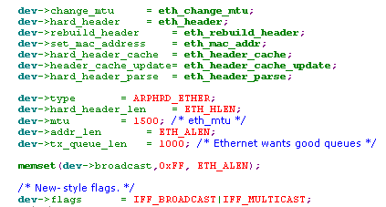
- 接着调用register_netdevice(dev)注册网络设备。它首先检查dev->init是否不为空，若是则会调用它。通常dev->init是驱动程序函数，它的主要作用在于根据I/O基地址寻找对应的网络适配器，如果找到了，则根据找到的网络适配器初始化net_device结构中的硬件部分（e.g., irq, base_addr, dma等）和于驱动相关的函数指针，并将该网卡的I/O address region注册。如果没有找到相应的网络适配器，则dev->init错误返回，这时该网络设备就会注册失败。如果dev->init成功，则网卡对应的硬件初始化就完成了，接着将该net_device结构插入链表尾部，且将dev->state设置为LINK_STATE_PRESENT，并且调用dev_init_scheduler()将网络设备的scheduler置为标准的FIFO，并且初始化定时器dev->watchdog_timer（并不启动定时器，只是初始化）：
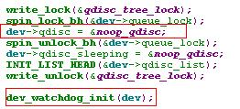
- 最后notifier_call_chain(&netdev_chain, NETDEV_REGISTER, dev)调用所有在通知链netdev_chain上注册过的方法，告知它们添加有新的网络设备。（关于通知链，本节后面讲述）。
补充资料：
unregister_netdevice(dev) removes the net_device structure passed as parameter from the list of registered network devices (dev_base). If the network device is still in active state (IFF_UP), it is now closed by the driver function dev->close(). Subsequently, it is searched in the list dev_base and removed. If it is not found, then the function returns an error message. Subsequently, the queuing discipline is released by dev_shutdown(), and all registered functions in the notification chain netdev_chain are informed about the NETDEV_UNREGISTER event. Subsequently, the destructor of the network driver is called, if it exists. Only the more recent network drivers have destructors, so we have to check periodically on whether existing references to the network device (dev->refcnt) disappeared for older drivers to be able to actually remove the network device.

1.2.2 Opening and Closing Network Devices
在注册了网络设备后，为了使用该网络设备，必须先激活它。Activate一般由ioctl()内核函数完成，它将dev->flags置为IFF_UP，并调用dev->open()驱动程序方法：
- dev->flags assumes the state IFF_UP.
- dev->state is set to LINK_START_START.
- The multicast state is activated by dev_mc_upload(). It calls dev->set_multicast_list(dev) to update the multicast list into the physical NIC controller.
- The queue and the scheduler of the network device are activated (dev_activate(dev)). At the same time, the method dev_watchdog_up(dev) starts the timer to detect transmission problems. The timer calls the method dev_watchdog() every dev->watchdog_timeo ticks to check that the network adapter works properly.
- The notification chain netdev_chain is informed about the event NETDEV_UP.
补充资料：
Deactivate一个网络设备也是用iocl命令，它调用方法dev_change_flags(dev, flags) 将dev->flags中IFF_UP标志去除.然后调用dev->close()方法：
- All methods in the notification chain netdev_chain are informed about the upcoming deactivation of the network device (NETDEV_GOING_DOWN) and can act accordingly.
- Next, dev_deactivate(dev) removes the packet scheduler dev->qdisc, and the LINK_STATE_START bit in dev->state is deleted. In addition, dev_watchdog_down() stops the timer used to detect transmission problems.
- The driver function dev->stop() deactivates the network adapter.
- Next, all protocols concerned are notified that the network device was stopped (notifier_call_chain(.., NETDEV_DOWN, ..)).
- Finally, the reference counter that points to the net_device structure is decremented by one.

1.2.3 Notification Chains for State Changes
网络设备可以动态的添加或移除，并且网络设备的状态以及属性会随时间改变(比如其MAC地址或名称改变了)，因为高层Protocol Instance会使用网络设备提供的服务，当网络设备的状态或属性改变时，必须将情况通知给相应的Protocol Instance. For this reason, protocols can register themselves to be notified of state changes in network devices. This concept is called notifier chains; it consists of a list (netdev_chain) of notifier_block structures:
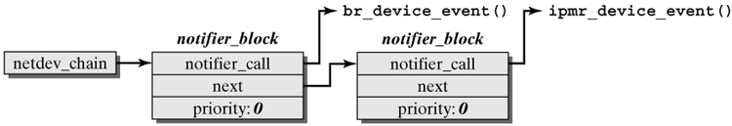
每个notifier_block结构有三个fields：
  - notifier_call is a pointer to a handling routine, which handles the notification about a network device's state change. Each protocol instance that stores states of network devices should have such a function. For example, the method br_device_event() is used for the instance of a transparent bridge，这些function都有相同类型的参数:
br_device_event(struct notifier_block *unused, unsigned long event, void *ptr)
注：ptr是指向state变化的net_device.
  - priority specifies a priority for processing of notifications.
  - next points to the next notifier_block element in the list.
If a state change occurs in a network device, then all handling routines stored in the list netdev_chain are called.
对于一个network device来说，那么到底有哪些Event可以通知呢？
Event | Specification
NETDEV_UP | Activates a network device (by dev_open)
NETDEV_DOWN | Deactivates a network device. As a consequence of this message, all references to this network device should be removed.
NETDEV_CHANGE | Informs that a network device changed its state.
NETDEV_REGISTER | A network device was registered but no instance of it has yet been opened.
NETDEV_UNREGISTER | Informs that a network driver was removed.
NETDEV_CHANGEMTU | The MTU (Maximum Transfer Unit) changed.
NETDEV_CHANGEADDR | The hardware address of a network device changed.
NETDEV_CHANGENAME | The name of a network device changed.
调用链是由notifier_call_chain(&netdev_chain, EVENT, dev)触发的：
notifier_call_chain(&netdev_chain, EVENT, dev) informs all handling methods registered in the list netdev_chain about the EVENT, where the events described above can occur. notifier_call_chain() is very simple. The linking in the list is used to call all registered functions, one after the other. If one of the functions called returns the constant NOTIFY_STOP_MASK, then the notification is stopped. This is useful to prevent there being several reactions to one event. Otherwise, all registered handling routines are always informed about the event each time this function is called.
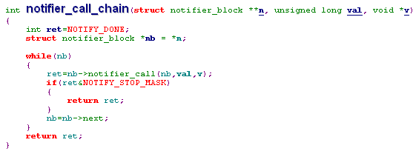
每当某个网络设备的state发生变化时，会Call调用链上所有注册的function，但每个function会判断是否对该变化进行特殊处理，如果不需要，则简单返回。cites：The registered handling method alone decides whether the event is meaningful for it.

1.3 Network Device Drivers
网络设备的驱动程序隐藏在net_device结构的函数指针下。本章简单介绍网络设备的驱动程序。
1）dev->init()：
它的主要任务是根据I/O port address寻找物理网络设备，并初始化找到的物理网络设备并设置net_device结构中的硬件相关部分（irq, dma, base_addr,）和驱动相关的函数指针。另外如果查找成功，则在内核中标识该I/O port address的region范围为该设备专用。
I/O port address或者是已知固定的，或者是设置的。如果是设置的，对于module的驱动程序来说，在加载module时，应该将I/O port address作为参数传递进来，并设置在dev-> base_addr中；对于内置在内核中的驱动，也可以在系统boot的时候传递参数，这些参数保存在dev_boot_setup列表中，在注册网络设备时，会设置到dev-> base_addr中。
dev->init()用于网络设备的注册中。init_netdev()会调用它。
2） dev->open():
它的主要任务是激活网络适配器。
  - 对网络适配器进行初始化，通常是对I/O端口编程，比如通过设置适配卡里寄存器的值来设置IRQ号以及DMA通道。
  - 清除dev->state中的__LINK_STATE_XOFF标志。这就意味着，此时可以向网络适配器传输数据了。
- dev->close():
它主要的作用是deactivate网络适配器。
  - Free分配给该网络适配器的IRQ和DMA通道。清除网络适配器的中断线并释放内核为其保留的I/O port address region.
  - 设置dev->state中的__LINK_STATE_XOFF标志。这就意味着，此时不能向网络适配器传输数据了。
- dev-> hard_start_xmit(skb, dev)
它的主要作用是将Packet传输给网络适配器，这样网络适配器可以将它发送出去。sk_buff中的Packet Data被复制到网络适配器的内部缓冲区中。事实上，driver维护着一个环形缓冲区(大小16~64)。dev-> hard_start_xmit的执行过程是：如果一个sk_buff要被发送，首先会将它链入该环形缓冲区，并将指向Packet Data的数据指针传递给适配器，最后向适配器发出传输命令，此时 hard_start_xmit返回。接着该sk_buff一直呆在该环形缓冲区中，直到网络适配器用中断通知该Packet传输完毕，中断程序首先将已发送成功的sk_buff从环形缓冲区中移除到Cache中。此时如果之前的__LINK_STATE_XOFF标志置位(置位，表示不能发送数据)，这时就将__LINK_STATE_XOFF清除，并触发NET_TX_SOFTIRQ软中断。
这样做的好处在于避免了sk_buff的copy。如果传输出现了错误，该sk_buff应该留在该环形缓冲区中，因为内核会重新尝试传递该包。
注意：当将一个sk_buff链入环形缓冲区后，要检查此时环形缓冲区是否已经满了，如果满了就应该将__LINK_STATE_XOFF标志置位，防止将来有更多的包发送过来。另外，只有当环形缓冲区不为满时才会调用dev->hard_start_xmit(skb, dev)，因此hard_start_xmit中并不检查环形缓冲区是否为满，它默认环形缓冲区不满。

5） 中断处理
有三种情况会使适配器产生中断：
1) 网络适配器接受并缓存了数据包。
2）网络适配器已经成功将一个Packet发送到了介质上。
3）遇到错误的情况。
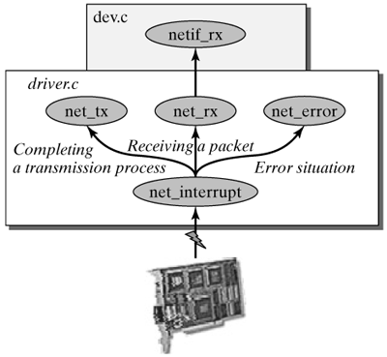
网络适配器的中断程序首先根据寄存器中的数据判断是发生了那种情况：
  - 发送成功确认。
如果是发送成功确认，中断程序首先将已发送成功的sk_buff从环形缓冲区中移除到Cache中。此时如果之前的__LINK_STATE_XOFF标志置位，这时就将__LINK_STATE_XOFF清除，并触发NET_TX_SOFTIRQ软中断。（In this case, 表示有Packet要发送但因环形缓冲区满而“滞留”在发送队列中，这时触发NET_TX_SOFTIRQ软中断会继续发送“滞留”在发送队列中的包）。
  - 接收到数据包并已缓冲到了内部缓冲区中。
如果接收到了数据包，中断程序首先会请求一个sk_buff数据结构（利用Cache），然后从适配器内部缓冲区中将数据Copy到sk_buff实例中的Packet Data Storage中，接着将该sk_buff实例链入Input Queue并触发NET_RX_SOFTIRQ软中断。
（注：每个CPU都维护一个Input Queue，另外将接受包的进一步处理放到软中断中。）
针对一次收到多个Packet的情况，这里设置了一个循环，最多一个中断可以同时接受10个Packet。
  - 遇到错误。
其实在中断处理程序中检测到错误一般用于statistics。
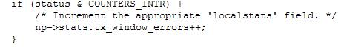
- Packet传输过程中的错误处理
如前所述，调用dev->open()时会激活watchdog_timer，这时每隔dev->watchdog_timeo滴答会调用相应的timer handler function：
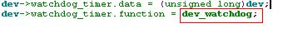
可以看到，timer handler function 为dev_watchdog，它会检查错误。如果__LINK_STATE_XOFF置位且(jiffies - dev->trans_start) > dev->watchdog_timeo，则说明上一个Packet传输中出现了错误，这时会调用dev->tx_timeout(dev)去处理它：
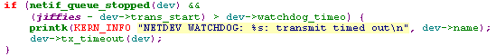
通常解决问题的唯一方法是重置并重新初始化网络适配器的全部硬件，Anyway，It should make the attempt to send the packets waiting in the queue.
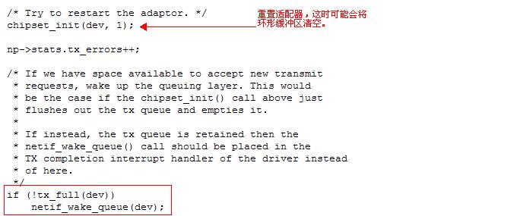
- nev->set_config(struct net_device *dev, struct ifmap *map)
我们可以利用nev->set_config动态地改变网络适配器使用的系统资源的配置，e.g., DMA, IRQ line等：
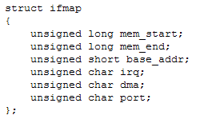
7）struct net_device_stats * dev->get_stats(struct net_device *dev)
它的作用是返回网络适配器的统计信息，统计信息是一个net_device_stats结构：
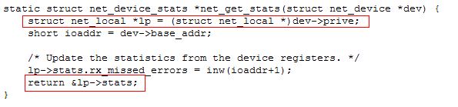
- dev->set_multicast_list()
对于网络适配器来说，接收介质上的包是它的责任。但这是由选择性的。网络适配器会检查帧头中的目标地址(Mac Address)，如果与自身Mac Address相同或是广播地址（0xFFFFFFFFFFFF)，则接收包。对于组播地址，网络适配器有一个组播地址列表，如果帧的源地址是组播地址列表中的一个，则接收它。
cites: A network device stores the list of active MAC group addresses in a list (dev- >mc_list). Whenever a new address is added or the state of the network device changes, then the driver method dev->set_multicast_list transfers this list to the adapter.
注：网络适配器如果处于promiscuous模式，则接收所有的包，不管是否发送给自己。另外网络适配器也可以接收所有的组播包，尽管它并没有subscribe这些组，这取决于dev->flag中IFF_ALLMULTI是否设置。
